Title of Paper of Extended Abstract
First Author^{1, a}, Second Author^{2,b} and Others^{3,c}
¹Full address of first author, including country
²Full address of second author, including country
³List all distinct addresses in the same way
ªemail, ^{b}email, ^{c}email (corresponding author)

Keywords: List the keywords covered in your paper up to 6 words arranged in alphabetical order.

ABSTRACT. This template explains and demonstrates how to prepare your extended abstract ICFMS 2016. The best is to read these instructions and follow the outline of this text. Please make the page settings of your word processor to A4 format (21 x 29,7 cm or 8 x 11 inches); with the margins: bottom 1.5 cm (0.59 in) and top 2.5 cm (0.98 in), right/left margins must be 2 cm (0.78 in). All abstracts should be written in English. Please, indicate the author making the presentation with an asterisk. The abstract should be written in MS Word format in single-spaced in 11 point Times New Roman. Do not indent the text paragraphs. Please, briefly explain the aim and scope of your study, your materials and methods, and the main conclusions of the study. Max 1 figure/photograph MUST be placed in the abstract. Authors are requested to submit Abstracts (max 1 page in the length) in electronic form (MS-Word) via email to the conference secretariat (3rd.icfms2016@gmail.com). The incorrect formats may result in your abstract being returned to you by e-mail. The scientific committee will select the contributions for oral and poster presentations.
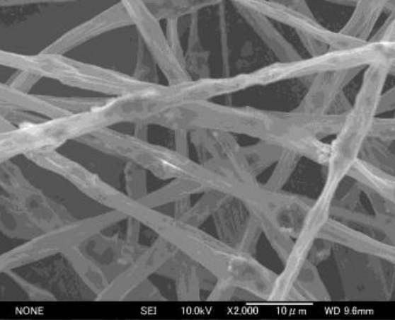
Figure 1. SEM image of chitosan nanofiber prepared by electrospinning

References
Reference an article:
[1] J. van der Geer, J.A.J. Hanraads, R.A. Lupton, The art of writing a scientific article, J. Sci. Commun. 163 (2000) 51-59.

Reference to a book:
[2] W. Strunk Jr., E.B. White, The Elements of Style, third ed., Macmillan, New York, 1979.

Reference to a chapter in an edited book:
[4] R.J. Ong, J.T. Dawley and P.G. Clem: submitted to Journal of Materials Research (2003)
[5] P.G. Clem, M. Rodriguez, J.A. Voigt and C.S. Ashley, U.S. Patent 6,231,666. (2001)
[6] Information on http://www.weld.labs.gov.cn

